**Carolina Simonet**

**Design Patterns**

1. Facade Pattern

Location:

ganttproject/src/main/java/net/sourceforge/ganttproject/task/dependency/TaskDependencyCollectionImpl.java

Explanation:

This class works with a subsystem of other classes to be easier to access all of them through this TaskDependencyCollectionImpl class.

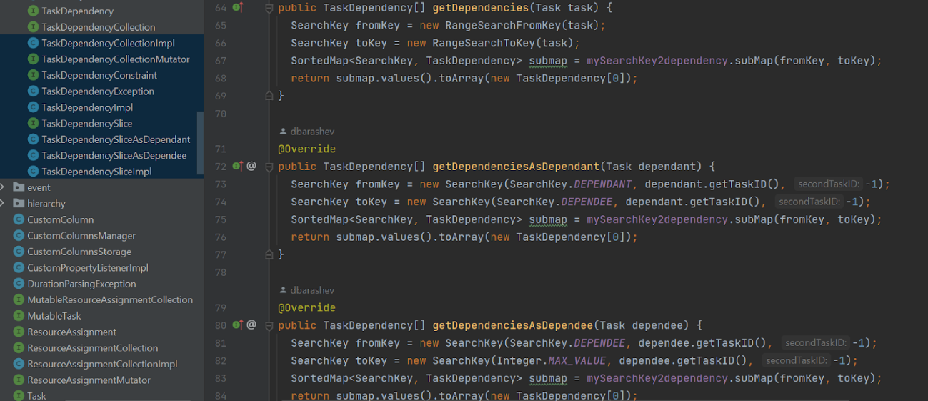

1. Command Pattern

    Location:

ganttproject/src/main/java/net/sourceforge/ganttproject/undo/UndoManagerImpl.java

Explanation:

Commands are being manipulated as objects, allows to do and undo operations.

1. Singleton Pattern

Location:

ganttproject/src/main/java/net/sourceforge/ganttproject/gui/ListAndFieldsPanel.java

Explanation:

Creates an object, the class has only one instance that generates a new box and returns it.

